Deploying Static Website using S3
select us-east-1 region

create a S3 bucket (bucket name,ACL enabled, uncheck block public access)

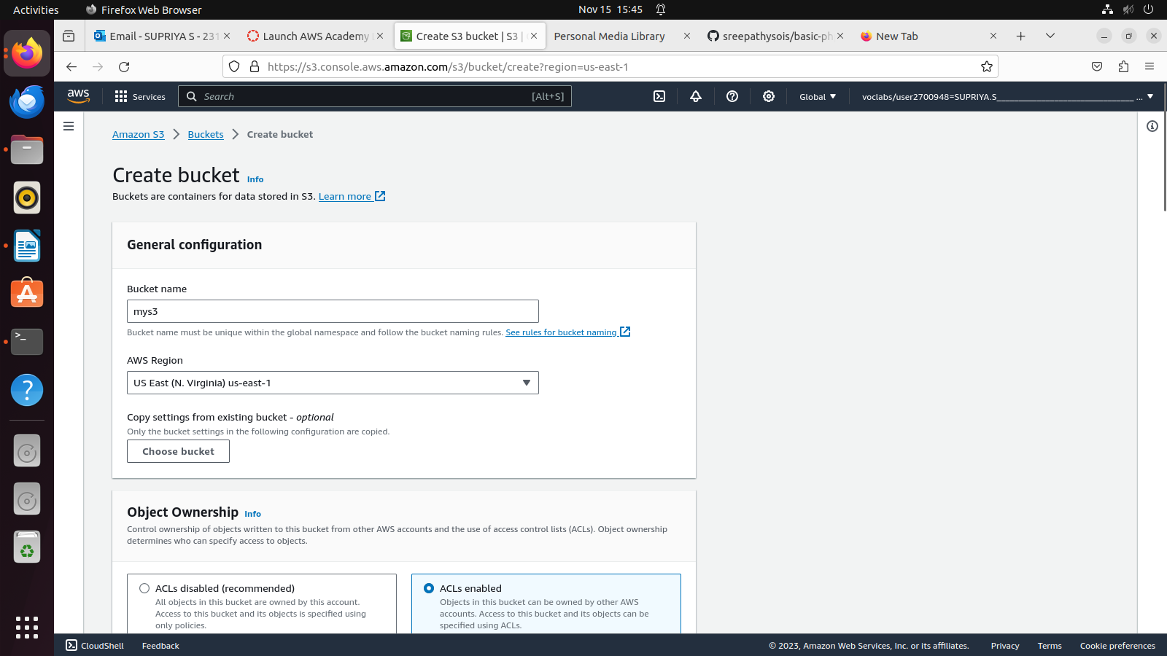
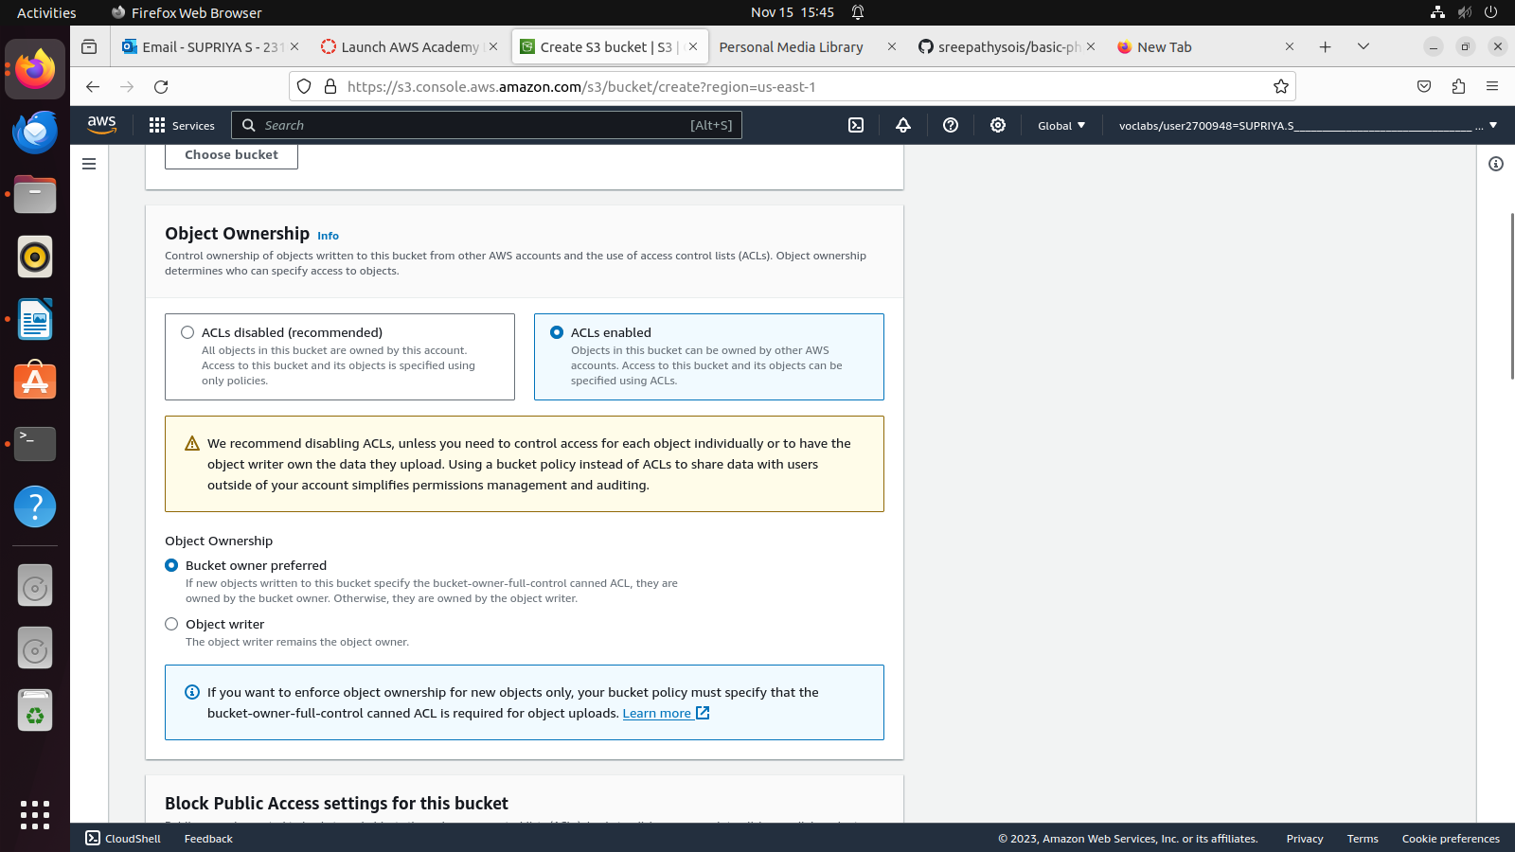
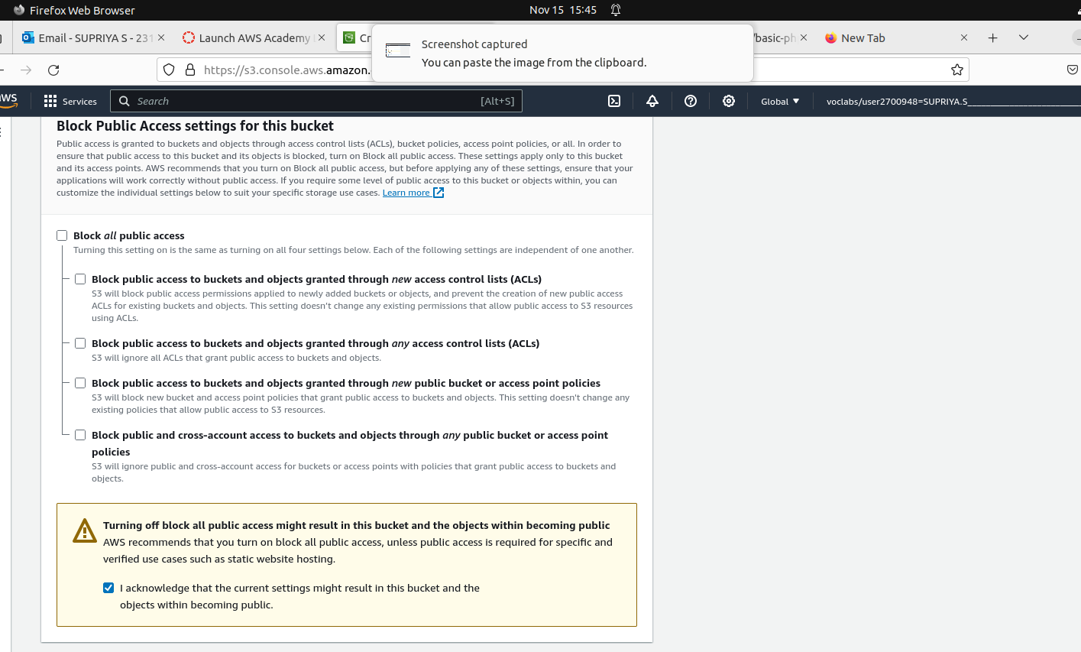
go inside this bucket and then upload the index.html file of html5up-paradigam-shift.

Then select index.html click action (make public using ACL)(make public)
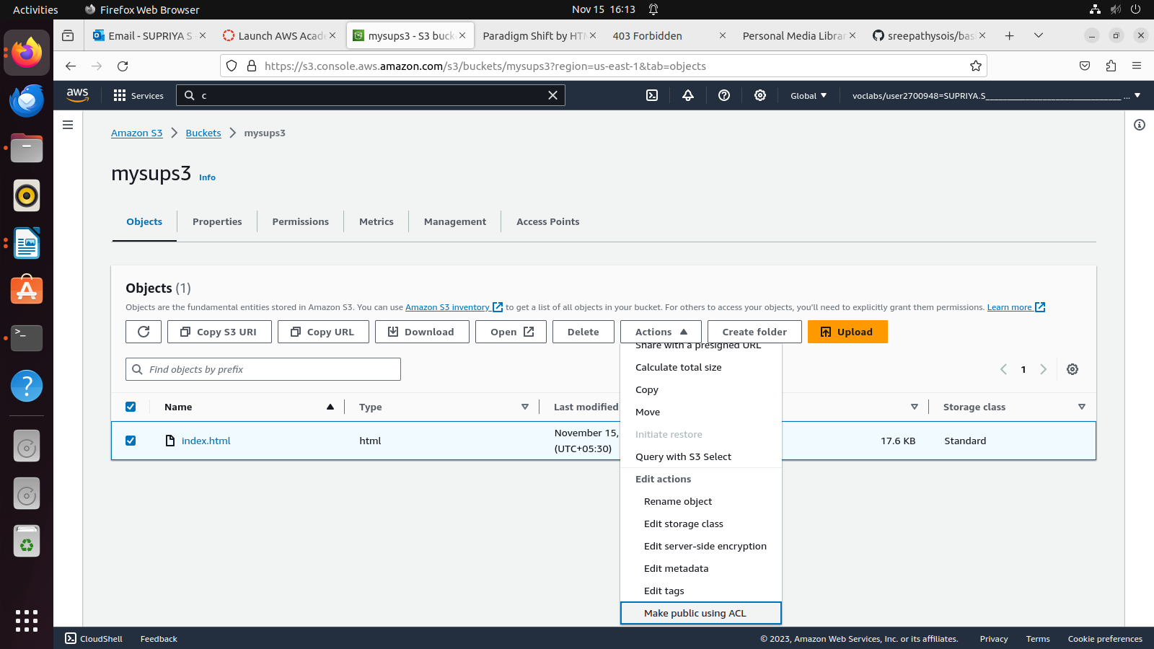
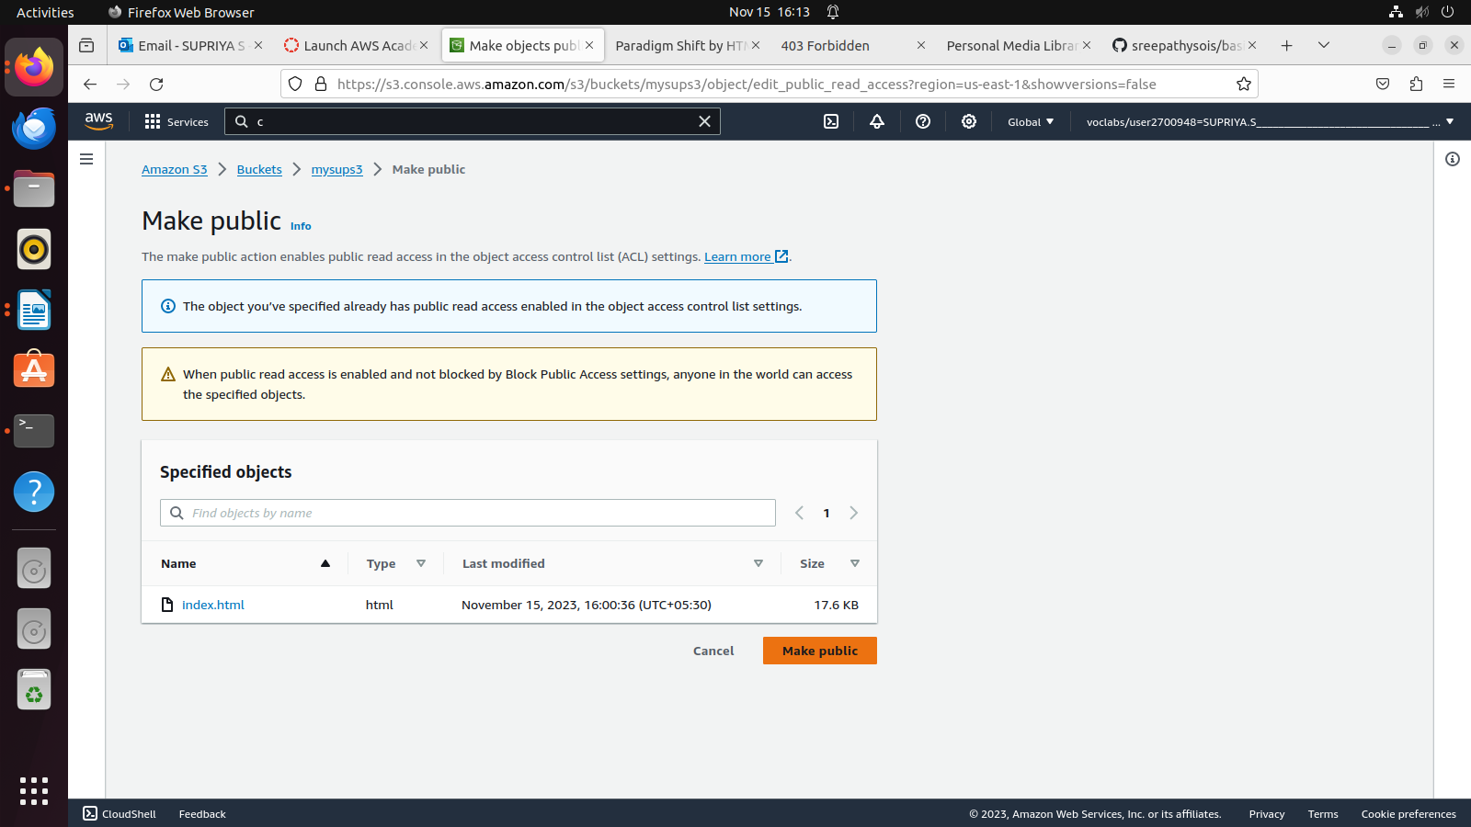

After this goto proprties of s3 bucket

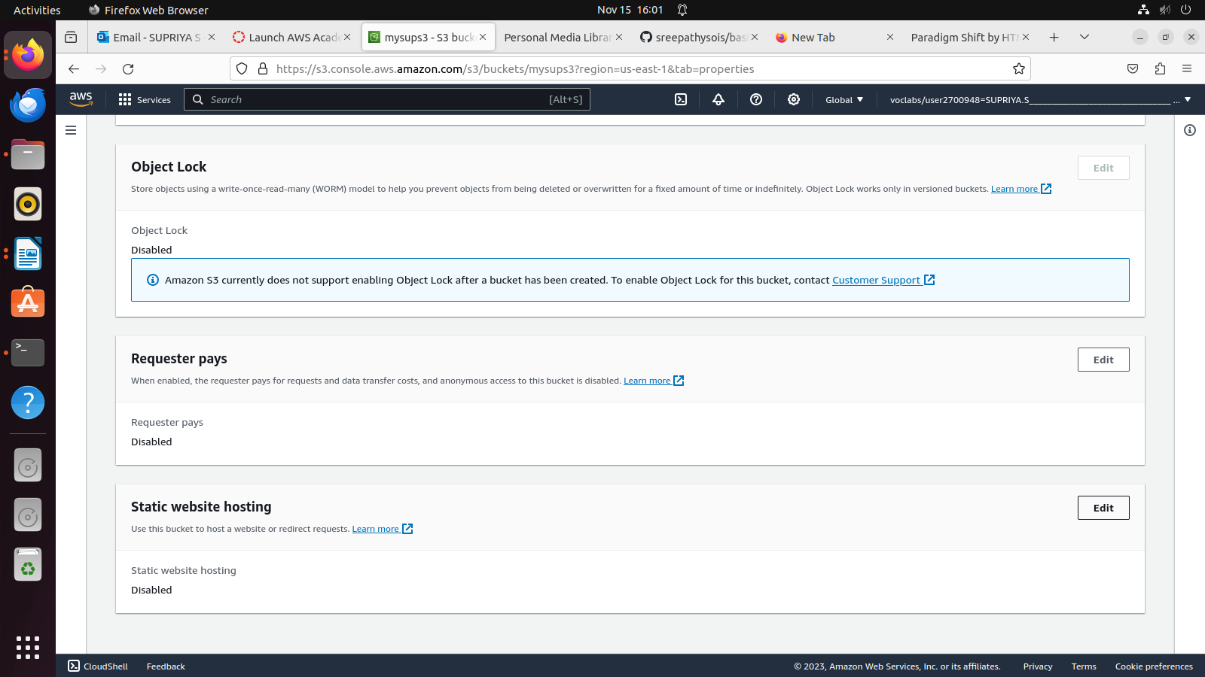
static website hosting (edit)

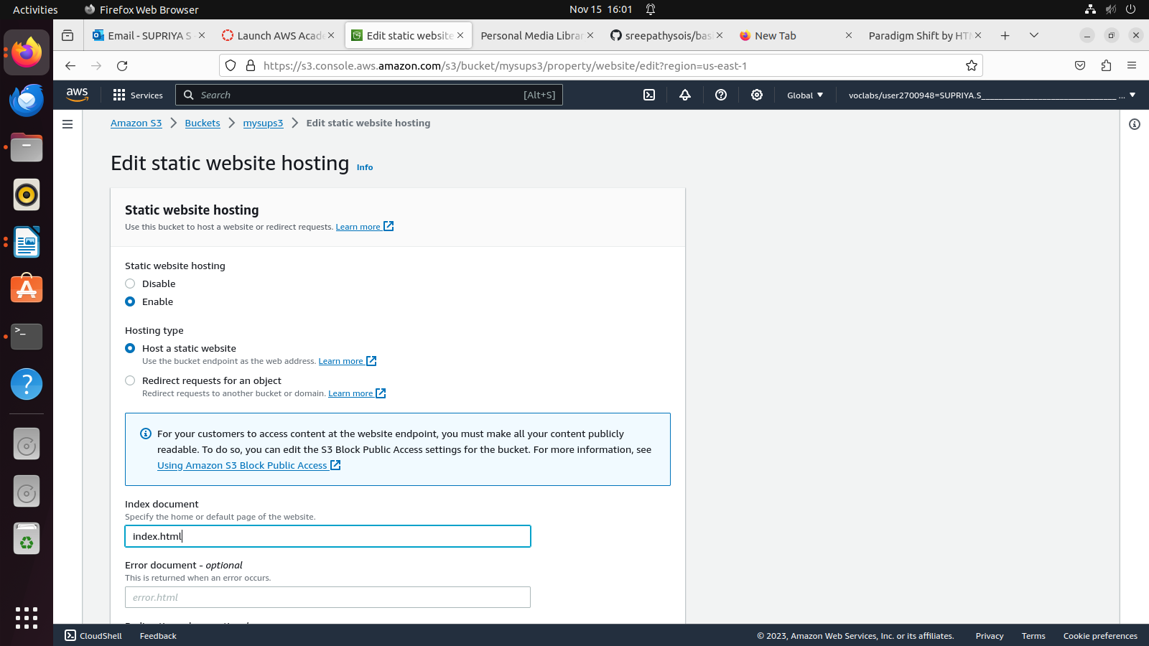

go to cloudfront create (auto detect , protocal http only , Enable Origin Shield(no), default route object (index.html) ) in Web Application Firewall select do not enable security create distribution .

Route 53

select create hosted zone(name)

goto create records

